**Ideation Phase**

**Empathize & Discover**

|  |  |
| --- | --- |
| Date | 27 June 2025 |
| Team ID | LTVIP2025TMID59638 |
| Project Name | TrafficTelligence: Advanced Traffic Volume Estimation with Machine Learning |
| Maximum Marks | 4 Marks |

**Empathy Map Canvas:**

An empathy map is a simple, easy-to-digest visual that captures knowledge about a user’s behaviours and attitudes.

It is a useful tool to helps teams better understand their users. Creating an effective solution requires understanding the true problem and the person who is experiencing it. The exercise of creating the map helps participants consider things from the user’s perspective along with his or her goals and challenges.

**TrafficTelligence: Advanced Traffic Volume Estimation with Machine Learning**

Traffic congestion is one of the most pressing urban challenges today. The surge in the number of private vehicles and underutilization of public transportation have significantly contributed to traffic-related issues. Monitoring traffic volume at various locations can empower governments to make informed decisions—such as expanding road infrastructure, building new routes, and enhancing multi-channel connectivity.

To address these challenges, **AI and Machine Learning** offer powerful tools for tracking vehicle counts, predicting traffic patterns, and even detecting traffic violations. By leveraging historical data and real-time inputs, ML models can generate early warnings for congestion hotspots, enabling timely interventions.

Therefore, it becomes essential to develop **robust ML algorithms** that can accurately predict traffic volume, minimize prediction errors, and align closely with real-world traffic observations. These predictive insights not only enhance day-to-day traffic management but also support long-term urban planning and infrastructure development.

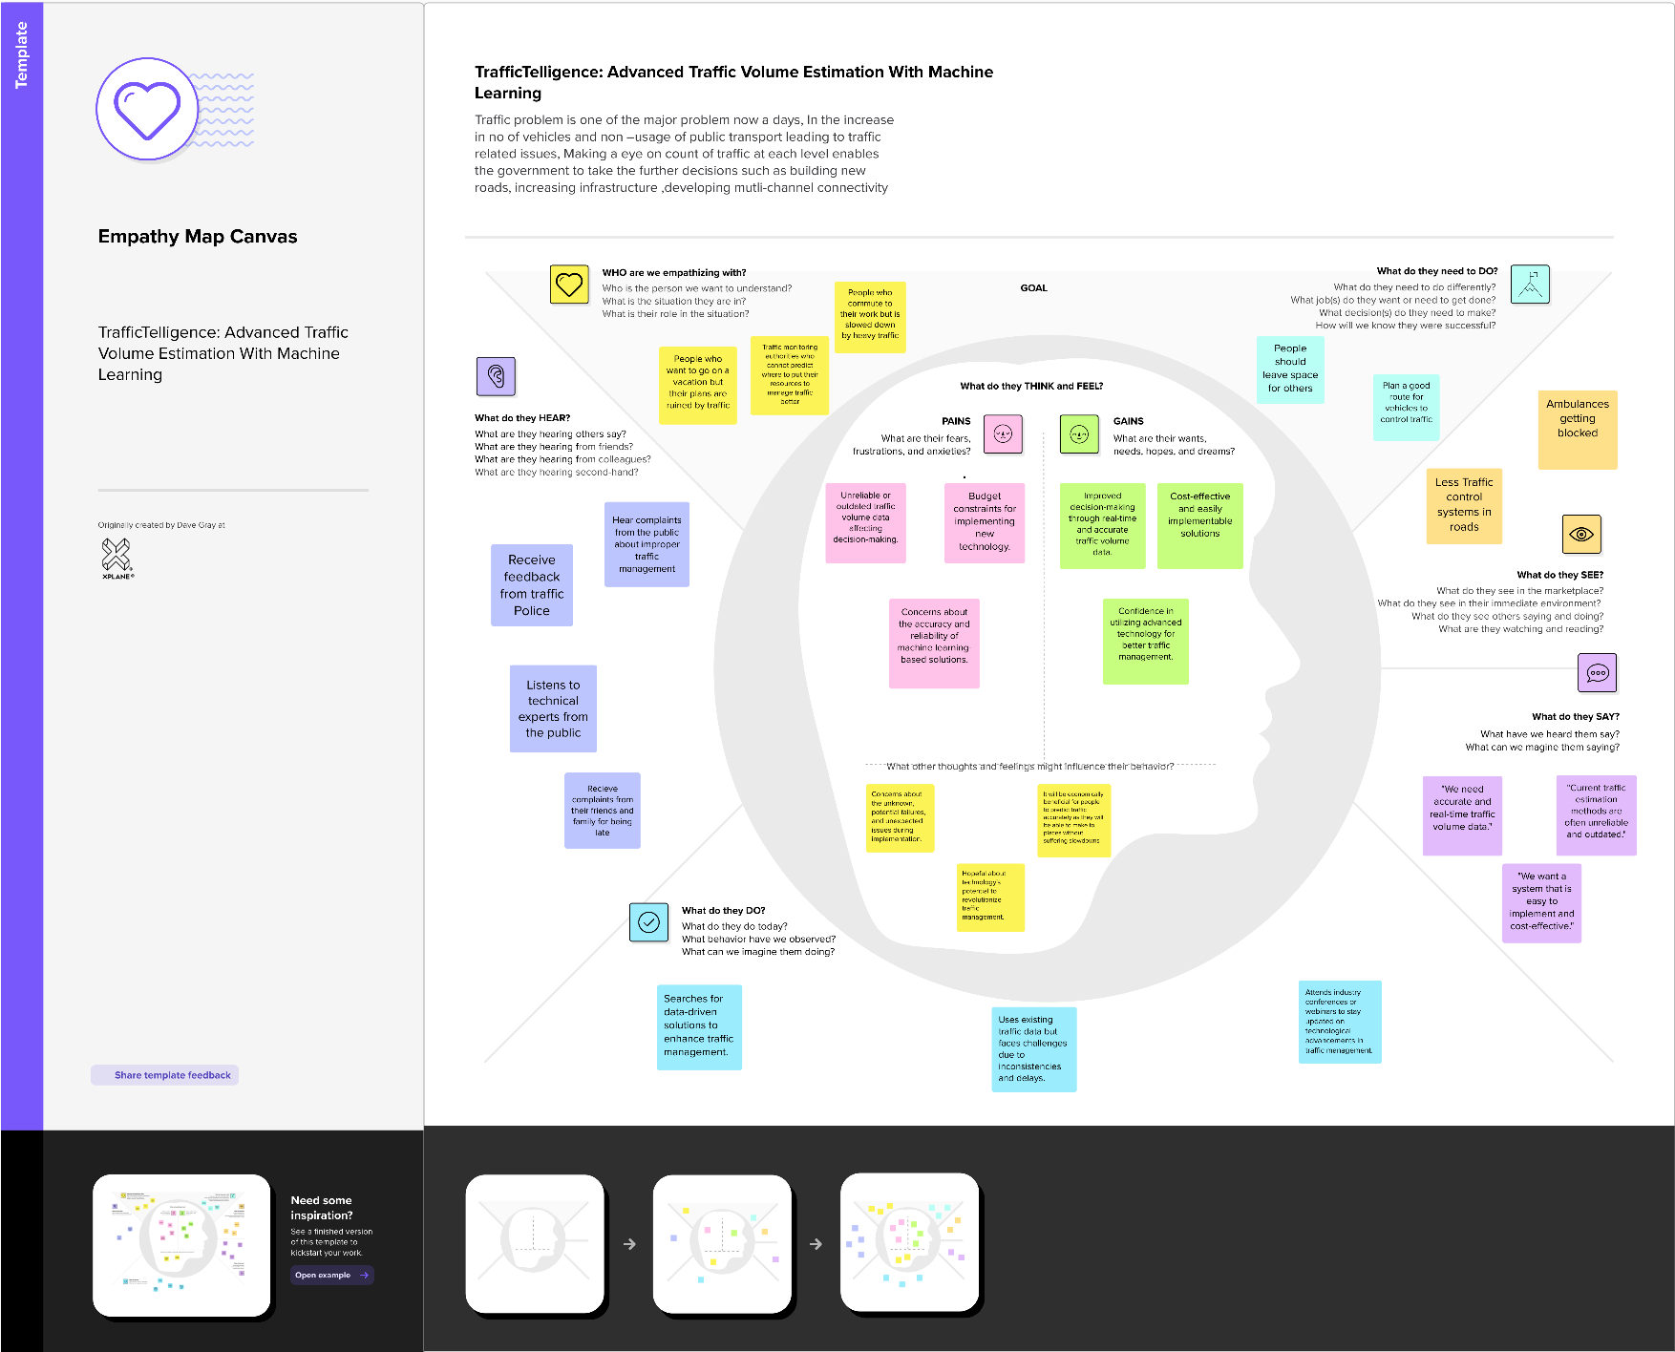**Empathy Canvas Map for the Project:**